**ESP 8266 Board install in Old IDE 1.0**

[HOME](https://randomnerdtutorials.com/) [ESP32](https://randomnerdtutorials.com/projects-esp32/) [ESP8266](https://randomnerdtutorials.com/projects-esp8266/) [ESP32-CAM](https://randomnerdtutorials.com/projects-esp32-cam/) [RASPBERRY PI](https://randomnerdtutorials.com/projects-raspberry-pi/) [MICROPYTHON](https://randomnerdtutorials.com/projects-esp32-esp8266-micropython/) [RPi PICO](https://randomnerdtutorials.com/projects-raspberry-pi-pico/) [ARDUINO](https://randomnerdtutorials.com/projects-arduino/) [REVIEWS](https://makeradvisor.com/)

**Installing ESP8266 Board in Arduino IDE (Windows, Mac OS X, Linux)**

The ESP8266 community created an add-on for the Arduino IDE that allows you to program the ESP8266 using the Arduino IDE and its programming language.

This tutorial shows how to install the ESP8266 board in Arduino IDE whether you’re using Windows, Mac OS X or Linux.

**Watch the Video Tutorial**

*This tutorial is available in video format (watch below) and in written format (continue reading this page).*

If you like the ESP8266 and want to build more projects, you can get my eBook: [Home Automation using ESP8266](https://randomnerdtutorials.com/home-automation-using-esp8266/).

**Prerequisites: Arduino IDE Installed**

Before starting this installation procedure, make sure you have the latest version of the Arduino IDE installed in your computer. If you don’t, uninstall it and install it again. Otherwise, it may not work.

Having the latest Arduino IDE software installed from [arduino.cc/en/Main/Software](https://www.arduino.cc/en/Main/Software), continue with this tutorial.

**Do you need an ESP8266 board?**You can [buy it here](https://makeradvisor.com/tools/esp8266-esp-12e-nodemcu-wi-fi-development-board/).

**Install ESP8266 Add-on in Arduino IDE**

To install the ESP8266 board in your Arduino IDE, follow these next instructions:

1. In your Arduino IDE, go to **File**> **Preferences**

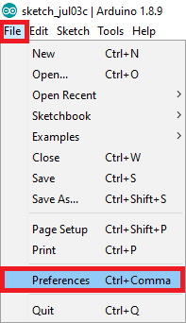

1. Enter **http://arduino.esp8266.com/stable/package_esp8266com_index.json** into the “Additional Boards Manager URLs” field as shown in the figure below. Then, click the “OK” button:

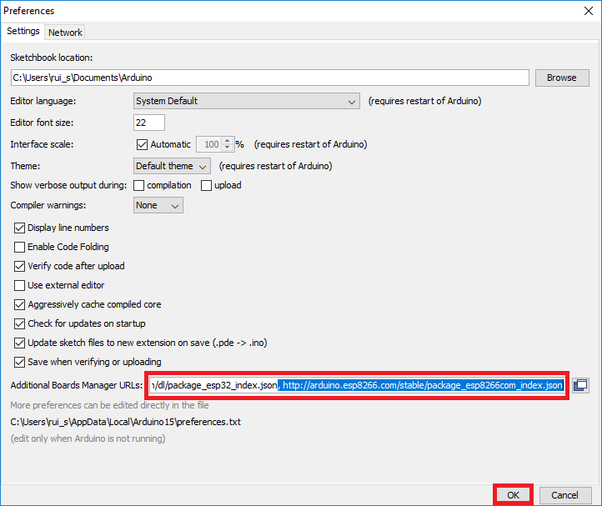

**Note:** if you already have the ESP32 boards URL, you can separate the URLs with a comma as follows:

https://dl.espressif.com/dl/package_esp32_index.json, http://arduino.esp8266.com/stable/package_esp8266com_index.json

1. Open the Boards Manager. Go to **Tools** > **Board** > **Boards Manager…**

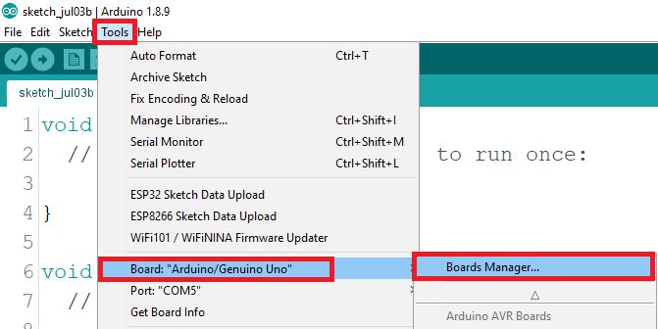

1. Search for **ESP8266** and press install button for the “**ESP8266 by ESP8266 Community**“:

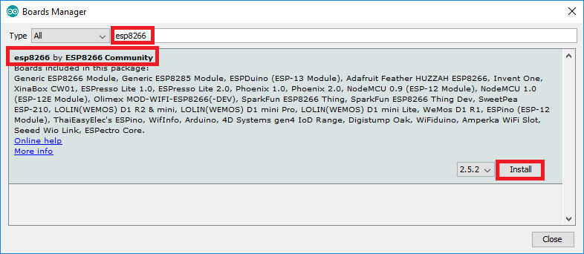

1. That’s it. It should be installed after a few seconds.

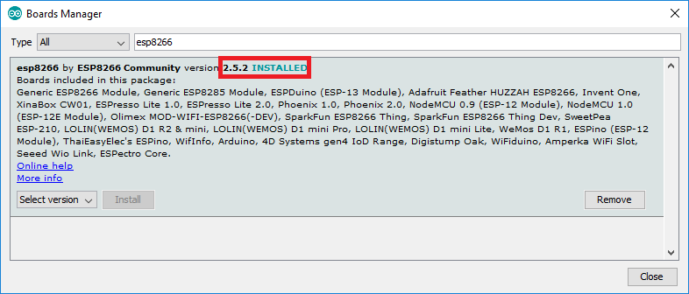

**Testing the Installation**

To test the ESP8266 add-on installation, let’s see if we can blink an LED with the ESP8266 using the Arduino programming language.

**Parts Required**

Here’s the hardware that you need to complete this project:

* [ESP8266](https://makeradvisor.com/tools/esp8266-esp-12e-nodemcu-wi-fi-development-board/) – read [Best ESP8266 Wi-Fi Development Boards](https://makeradvisor.com/best-esp8266-wi-fi-development-board/)
* [LED](https://makeradvisor.com/tools/3mm-5mm-leds-kit-storage-box/)
* [330 Ohm resistor](https://makeradvisor.com/tools/resistors-kits/)
* [Breadboard](https://makeradvisor.com/tools/mb-102-solderless-breadboard-830-points/)
* [Jumper wires](https://makeradvisor.com/tools/jumper-wires-kit-120-pieces/)

If you’re using an [ESP8266-01](https://makeradvisor.com/tools/esp-01-wi-fi-board/), you also need an [FTDI programmer](https://makeradvisor.com/tools/ftdi-programmer-board/) to upload code.

You can use the preceding links or go directly to [MakerAdvisor.com/tools](https://makeradvisor.com/tools/?utm_source=rnt&utm_medium=post&utm_campaign=post) to find all the parts for your projects at the best price!

](https://makeradvisor.com/tools/?utm_source=rnt&utm_medium=post&utm_campaign=post)

**Uploading the Sketch**

**Uploading the Sketch to the ESP-12E**

If you’re using an ESP-12E NodeMCU Kit, uploading the sketch is very simple, since it has built-in programmer. Plug your board to your computer. Make sure you have the right board selected:

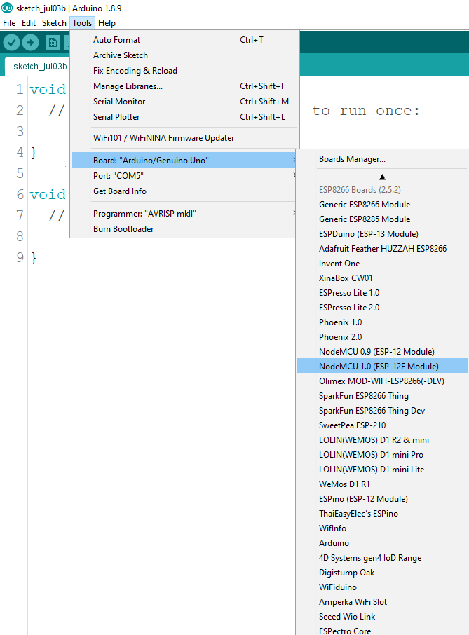

You also need to select the Port:

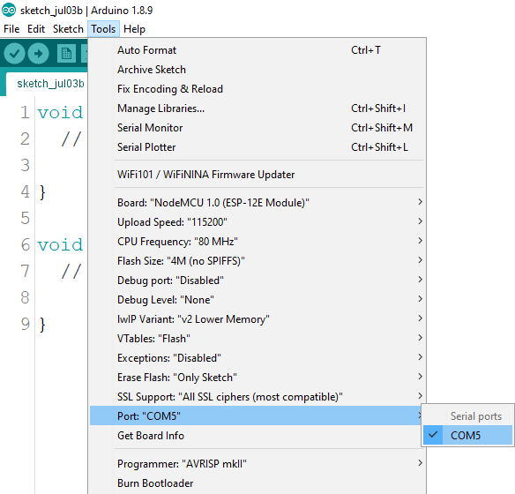

Then, copy the code provided:

/*********

Rui Santos

Complete project details at https://randomnerdtutorials.com

*********/

int pin = 2;

void setup() {

// initialize GPIO 2 as an output.

pinMode(pin, OUTPUT);

}

// the loop function runs over and over again forever

void loop() {

digitalWrite(pin, HIGH); // turn the LED on (HIGH is the voltage level)

delay(1000); // wait for a second

digitalWrite(pin, LOW); // turn the LED off by making the voltage LOW

delay(1000); // wait for a second

}

[View raw code](https://github.com/RuiSantosdotme/Random-Nerd-Tutorials/raw/master/Projects/blink_led_esp8266.ino)

Click the “Upload” button in the Arduino IDE and wait a few seconds until you see the message “Done uploading.” in the bottom left corner.

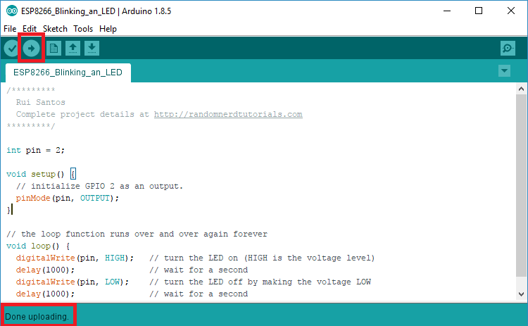

**Uploading the Sketch to the ESP-01**

Uploading code to the ESP-01 requires establishing a serial communication between your ESP8266 and a FTDI Programmer as shown in the schematic diagram below.

[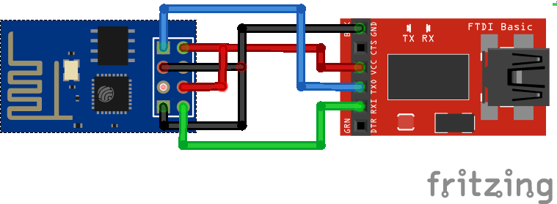](https://i0.wp.com/randomnerdtutorials.com/wp-content/uploads/2015/02/ESP8266-Flasher.png?quality=100&strip=all&ssl=1)

The following table shows the connections you need to make between the ESP8266 and the FTDI programmer.

|  |  |
| --- | --- |
| **ESP8266** | **FTDI programmer** |
| RX | TX |
| TX | RX |
| CH_PD | 3.3V |
| GPIO 0 | GND |
| VCC | 3.3V |
| GND | GND |

If you have a brand new FTDI Programmer and you need to install your FTDI drivers on Windows PC, visit this website for the official drivers: <http://www.ftdichip.com/Drivers/VCP.htm>.

Then, you just need to connect the FTDI programmer to your computer, and upload the sketch to your ESP8266 board. You should see the “Done Uploading” message after a few seconds.

**Schematic**

**If you’re using an ESP8266-12E**

Connect an LED to your ESP8266, as shown in the following schematic diagram. The LED should be connected to GPIO 2 (D4).

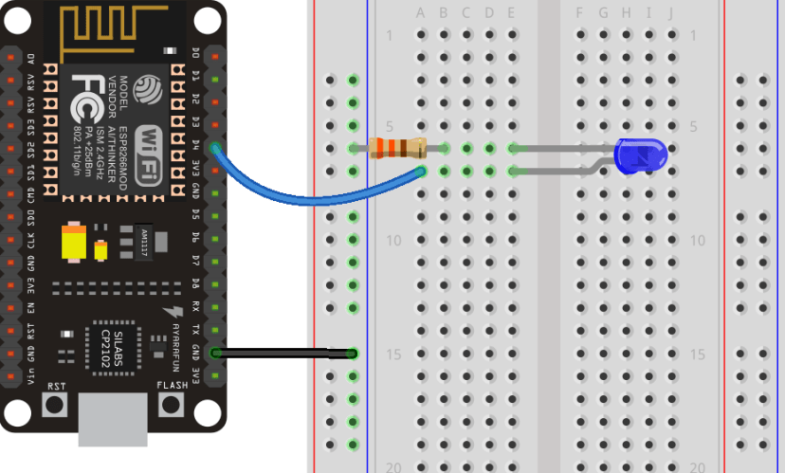

**If you’re using an ESP8266-01**

If you’re using the ESP8266-01 assemble the following circuit.

[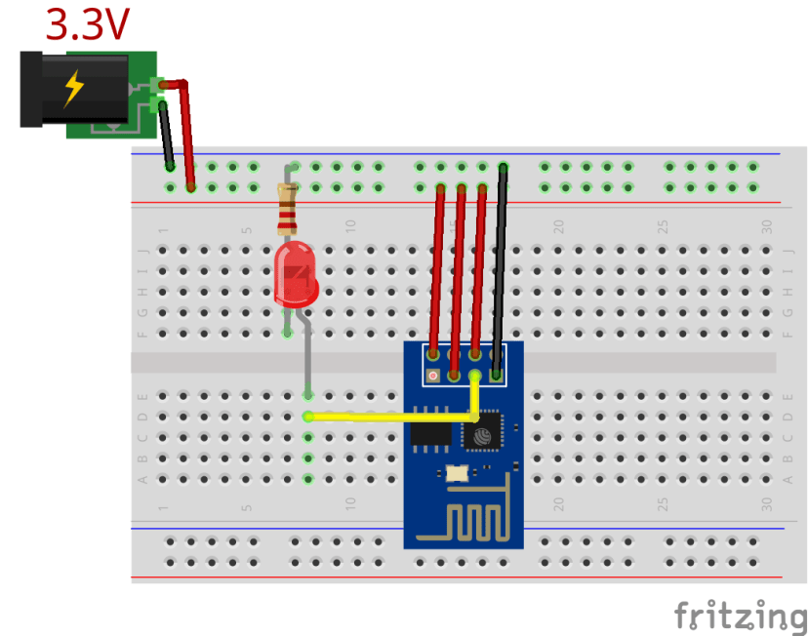](https://i0.wp.com/randomnerdtutorials.com/wp-content/uploads/2015/09/ESP8266-Blinking-an-LED.png?quality=100&strip=all&ssl=1)

If everything went well, your LED should be blinking every 1 second.

**Troubleshooting**

**1)** If you try to upload a new sketch to your ESP8266 and you get this error message “*esptool.FatalError: Failed to connect to ESP8266: Timed out waiting for packet header*“. It means that your ESP8266 is not in flashing/uploading mode.

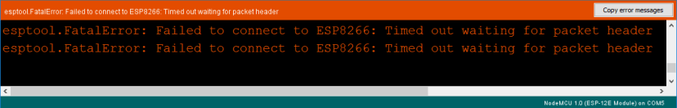

Having the right board name and COM port selected, follow these steps:

* Hold-down the “**BOOT/FLASH**” button in your ESP8266 development board
* Press the “**Upload**” button in the Arduino IDE to upload your sketch:

Arduino IDE uploading new sketch to ESP32

* When you see the  “**Connecting….**” message in your Arduino IDE, release the finger from the “**BOOT/FLASH**” button
* After that, you should see the “**Done uploading**” message

Your ESP8266 should have the new sketch running. Press the “**ENABLE/RESET**” button to restart the ESP8266 and run the new uploaded sketch.

**2)** If you get the error “COM Port not found/not available”, you might need to install the CP210x Drivers:

* [Install USB Drivers – CP210x USB to UART Bridge (Windows PC)](https://randomnerdtutorials.com/install-esp32-esp8266-usb-drivers-cp210x-windows/)
* [Install USB Drivers – CP210x USB to UART Bridge (Mac OS X)](https://randomnerdtutorials.com/install-esp32-esp8266-usb-drivers-cp210x-mac-os/)

**Wrapping Up**

This is a quick guide that illustrates how to prepare your Arduino IDE for the ESP8266 on a Windows PC, Mac OS X, or Linux computer.

Next, you might want to read: [Getting started with ESP8266](https://randomnerdtutorials.com/getting-started-with-esp8266-wifi-transceiver-review/).

That’s it, you’re ready to start building your own IoT projects with the ESP8266!

* [**Home Automation Using ESP8266**](https://randomnerdtutorials.com/home-automation-using-esp8266/)
* [ESP8266 Web Server Step-by-step](https://randomnerdtutorials.com/esp8266-web-server/)
* [ESP8266 Wi-Fi Button – DIY Amazon Dash Button Clone](https://randomnerdtutorials.com/esp8266-wi-fi-button-diy-amazon-dash-button-clone/)
* [ESP8266 Daily Task – Publish Temperature Readings to ThingSpeak](https://randomnerdtutorials.com/esp8266-daily-task-publish-temperature-readings-to-thingspeak/)
* [ESP8266 Weather Forecaster](https://randomnerdtutorials.com/esp8266-weather-forecaster/)
* [Nextion Display with ESP8266 – Touchscreen User Interface for Node-RED](https://randomnerdtutorials.com/nextion-display-with-esp8266-touchscreen-user-interface-for-node-red/)
* [More ESP8266 projects…](https://randomnerdtutorials.com/projects-esp8266/)

Do you have any questions? Leave a comment below!

Thanks for reading. If you like this post probably you might like my next ones, so [subscribe to my newsletter](https://randomnerdtutorials.com/download).

](https://randomnerdtutorials.com/pcbway)

[](https://randomnerdtutorials.com/smart-home-ebook/)

[**SMART HOME with Raspberry Pi, ESP32, ESP8266 [eBook]**](https://randomnerdtutorials.com/smart-home-ebook/)

Learn how to build a home automation system and we’ll cover the following main subjects: Node-RED, Node-RED Dashboard, Raspberry Pi, ESP32, ESP8266, MQTT, and InfluxDB database [**DOWNLOAD »**](https://randomnerdtutorials.com/smart-home-ebook/)

**Recommended Resources**

](https://randomnerdtutorials.com/build-a-home-automation-system-for-100/)

[**Build a Home Automation System from Scratch »**](https://randomnerdtutorials.com/build-a-home-automation-system-for-100/)With Raspberry Pi, ESP8266, Arduino, and Node-RED.

[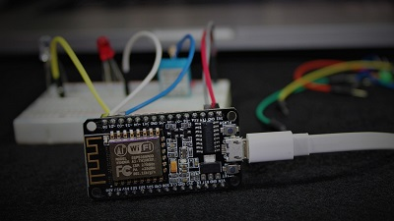](https://randomnerdtutorials.com/home-automation-using-esp8266/)

[**Home Automation using ESP8266 eBook and video course »**](https://randomnerdtutorials.com/home-automation-using-esp8266/)Build IoT and home automation projects.

[**Arduino Step-by-Step Projects »**](https://randomnerdtutorials.com/arduino-step-by-step-projects/)Build 25 Arduino projects with our course, even with no prior experience!

**What to Read Next…**

[ESP-MESH with ESP32 and ESP8266: Getting Started (painlessMesh library)](https://randomnerdtutorials.com/esp-mesh-esp32-esp8266-painlessmesh/)

[ESP8266 NodeMCU Access Point (AP) for Web Server](https://randomnerdtutorials.com/esp8266-nodemcu-access-point-ap-web-server/)

[ESP32 Save Data Permanently using Preferences Library](https://randomnerdtutorials.com/esp32-save-data-permanently-preferences/)

**Enjoyed this project? Stay updated by subscribing our newsletter!**

Top of Form

SUBSCRIBE

Bottom of Form

**74 thoughts on “Installing ESP8266 Board in Arduino IDE (Windows, Mac OS X, Linux)”**

1. A person with a white circle

   AI-generated content may be incorrect.

**amirreza**

[September 21, 2015 at 7:11 am](https://randomnerdtutorials.com/how-to-install-esp8266-board-arduino-ide/#comment-268495)

Hi  
I need some help…!  
I want o using esp8266 esp-07 standalone and program it with the arduino ids but i can’t even compile the examples with the ide and I fallow all the instructions in the github website and also your website and the error is compile error please help me how can i fix this problem.  
thankes alot

[Reply](https://randomnerdtutorials.com/how-to-install-esp8266-board-arduino-ide/#comment-268495)

* + A person smiling at camera

    AI-generated content may be incorrect.

[**Rui Santos**](https://randomnerdtutorials.com/)

[September 24, 2015 at 1:52 pm](https://randomnerdtutorials.com/how-to-install-esp8266-board-arduino-ide/#comment-268868)

Can you see the ESP8266 boards in the tools section? Have you restarted your Arduino IDE? Which error is occurring?

[Reply](https://randomnerdtutorials.com/how-to-install-esp8266-board-arduino-ide/#comment-268868)

1. A person with a white circle

   AI-generated content may be incorrect.

**amirreza**

[September 21, 2015 at 7:11 am](https://randomnerdtutorials.com/how-to-install-esp8266-board-arduino-ide/#comment-268496)

Hi  
I need some help…!  
I want o using esp8266 esp-07 standalone and program it with the arduino ids but i can’t even compile the examples with the ide and I fallow all the instructions in the github website and also your website and the error is compile error please help me how can i fix this problem.  
thankes alot

[Reply](https://randomnerdtutorials.com/how-to-install-esp8266-board-arduino-ide/#comment-268496)

* + A person with a white circle

    AI-generated content may be incorrect.

**Camilo**

[August 16, 2022 at 9:10 pm](https://randomnerdtutorials.com/how-to-install-esp8266-board-arduino-ide/#comment-776152)

hola confirma que no tengas otra librería declarada, me pasaba lo mismo con un programa que usaba anteriormente y al no tener instalada esa librería en especifico, no podía compilar.

#include <ESP8266WiFi.h>

la idea es que solo incluyas esa librería si tienes otra, elimínala y haz la prueba para ver si compila.

[Reply](https://randomnerdtutorials.com/how-to-install-esp8266-board-arduino-ide/#comment-776152)

1. A person with a white circle

   AI-generated content may be incorrect.

**sami alfarra**

[February 18, 2016 at 4:52 am](https://randomnerdtutorials.com/how-to-install-esp8266-board-arduino-ide/#comment-278016)

please where is code Rui

[Reply](https://randomnerdtutorials.com/how-to-install-esp8266-board-arduino-ide/#comment-278016)

* + A person smiling at camera

    AI-generated content may be incorrect.

[**Rui Santos**](https://randomnerdtutorials.com/)

[February 18, 2016 at 12:18 pm](https://randomnerdtutorials.com/how-to-install-esp8266-board-arduino-ide/#comment-278033)

It’s on this exact page

[Reply](https://randomnerdtutorials.com/how-to-install-esp8266-board-arduino-ide/#comment-278033)

* + - A person with a white circle

      AI-generated content may be incorrect.

**suppaman80**

[February 27, 2016 at 9:33 am](https://randomnerdtutorials.com/how-to-install-esp8266-board-arduino-ide/#comment-278507)

hi rui  
but for start the led blink i remove the gpio 0 from 3v  
the image is incorrect 🙂  
thankes alot for all

[Reply](https://randomnerdtutorials.com/how-to-install-esp8266-board-arduino-ide/#comment-278507)

* + - * A person smiling at camera

        AI-generated content may be incorrect.

[**Rui Santos**](https://randomnerdtutorials.com/)

[February 29, 2016 at 12:12 am](https://randomnerdtutorials.com/how-to-install-esp8266-board-arduino-ide/#comment-278561)

The GPIO 0 connected to VCC is to make that your ESP doesn’t boot in flash/upload mode.

Thanks!  
Rui

[Reply](https://randomnerdtutorials.com/how-to-install-esp8266-board-arduino-ide/#comment-278561)

1. A person with a white circle

   AI-generated content may be incorrect.

**Oscar Mayorquin**

[March 13, 2016 at 6:36 am](https://randomnerdtutorials.com/how-to-install-esp8266-board-arduino-ide/#comment-279110)

Hi Rui

When I try to upload the code, the compilation give me some errors

warning: espcomm_sync failed  
error: espcomm_open failed  
error: espcomm_upload_mem failed

Do you know because this?

[Reply](https://randomnerdtutorials.com/how-to-install-esp8266-board-arduino-ide/#comment-279110)

* + A person smiling at camera

    AI-generated content may be incorrect.

[**Rui Santos**](https://randomnerdtutorials.com/)

[March 14, 2016 at 12:47 pm](https://randomnerdtutorials.com/how-to-install-esp8266-board-arduino-ide/#comment-279172)

Hi Oscar,  
Your ESP8266 is not in flash mode or it’s having a power issue.  
Can you read this troubleshooting guide? <https://randomnerdtutorials.com/esp8266-troubleshooting-guide/>

I hope this helps,  
Rui

[Reply](https://randomnerdtutorials.com/how-to-install-esp8266-board-arduino-ide/#comment-279172)

* + - A person with a white circle

      AI-generated content may be incorrect.

**Oscar Mayorquin**

[March 15, 2016 at 6:36 am](https://randomnerdtutorials.com/how-to-install-esp8266-board-arduino-ide/#comment-279211)

Thanks Rui,

I’ve to flash my ESP again and upload the code, but the LED isn’t blinking, and I really doing step by step.

[Reply](https://randomnerdtutorials.com/how-to-install-esp8266-board-arduino-ide/#comment-279211)

1. A person with a white circle

   AI-generated content may be incorrect.

[**Stephen Griswold**](https://www.facebook.com/gelfling6)

[May 6, 2016 at 10:01 pm](https://randomnerdtutorials.com/how-to-install-esp8266-board-arduino-ide/#comment-283095)

One note, as someone who just tried this, and…. bombed… This will require one of the 1.6.x or newer versions of the Arduino IDE.. I’m running a UBUNTU desktop, and it’s version for the IDE is 1.0.5… Not going to work! (and for some reason, they install the IDE in an odd fashion, making it tougher to install the newer version.)

[Reply](https://randomnerdtutorials.com/how-to-install-esp8266-board-arduino-ide/#comment-283095)

* + A person with a white circle

    AI-generated content may be incorrect.

**Mikael**

[May 14, 2020 at 10:57 am](https://randomnerdtutorials.com/how-to-install-esp8266-board-arduino-ide/#comment-456562)

Hello is there a way to password protect my esp’s access point. Thanks.

[Reply](https://randomnerdtutorials.com/how-to-install-esp8266-board-arduino-ide/#comment-456562)

1. A person with a white circle

   AI-generated content may be incorrect.

**Blagoja Andonoski**

[August 12, 2016 at 1:23 pm](https://randomnerdtutorials.com/how-to-install-esp8266-board-arduino-ide/#comment-288852)

Hello MR. Rui Santos  
I am a novice at Arduino projects.  
Install ESP8266 according to your instructions and uplaud to get the following information:  
I am a novice at Arduino projects.  
Install ESP8266 according to your instructions and uplaud to get the following information:  
I am a novice at Arduino projects.  
Install ESP8266 according to your instructions and uplaud to get the following information:  
warning: espcomm_sync failed  
error: espcomm_open failed  
error: espcomm_upload_mem failed  
error: espcomm_upload_mem failed

Please help.

Best Regaeds

Blagoja Andonoski

[Reply](https://randomnerdtutorials.com/how-to-install-esp8266-board-arduino-ide/#comment-288852)

* + A person smiling at camera

    AI-generated content may be incorrect.

[**Rui Santos**](https://randomnerdtutorials.com/)

[August 12, 2016 at 7:31 pm](https://randomnerdtutorials.com/how-to-install-esp8266-board-arduino-ide/#comment-288882)

This might help: <https://randomnerdtutorials.com/esp8266-troubleshooting-guide/>

[Reply](https://randomnerdtutorials.com/how-to-install-esp8266-board-arduino-ide/#comment-288882)

1. A person with a white circle

   AI-generated content may be incorrect.

**AYYOOB VK**

[August 18, 2016 at 9:01 am](https://randomnerdtutorials.com/how-to-install-esp8266-board-arduino-ide/#comment-289098)

Sketch uses 222,241 bytes (44%) of program storage space. Maximum is 499,696 bytes.  
Global variables use 31,576 bytes (38%) of dynamic memory, leaving 50,344 bytes for local variables. Maximum is 81,920 bytes.  
warning: espcomm_sync failed  
error: espcomm_open failed  
error: espcomm_upload_mem failed  
error: espcomm_upload_mem failed

[Reply](https://randomnerdtutorials.com/how-to-install-esp8266-board-arduino-ide/#comment-289098)

* + A person smiling at camera

    AI-generated content may be incorrect.

[**Rui Santos**](https://randomnerdtutorials.com/)

[August 24, 2016 at 9:00 am](https://randomnerdtutorials.com/how-to-install-esp8266-board-arduino-ide/#comment-289296)

Your ESP is not establishing a serial communication with your computer, so it can’t upload any code.  
I hope this post helps: <https://randomnerdtutorials.com/esp8266-troubleshooting-guide/>

[Reply](https://randomnerdtutorials.com/how-to-install-esp8266-board-arduino-ide/#comment-289296)

1. A person in a suit

   AI-generated content may be incorrect.

[**Prithul**](https://facebook.com/iqbalsamin.prithul)

[September 22, 2016 at 1:27 pm](https://randomnerdtutorials.com/how-to-install-esp8266-board-arduino-ide/#comment-290727)

Hi Rui!

I have NodeMCU installed on my ESP-01.  
Can’t I use Arduino IDE with it? If I can then how? if I can’t than what shall I do to be able to use Arduino IDE?

Greeings,  
Prithul

[Reply](https://randomnerdtutorials.com/how-to-install-esp8266-board-arduino-ide/#comment-290727)

* + A person smiling at camera

    AI-generated content may be incorrect.

[**Rui Santos**](https://randomnerdtutorials.com/)

[October 2, 2016 at 11:30 am](https://randomnerdtutorials.com/how-to-install-esp8266-board-arduino-ide/#comment-291276)

You can use the Arduino IDE, if you follow this tutorial will overwrite the NodeMCU firmware with the Arduino IDE blink sketch

[Reply](https://randomnerdtutorials.com/how-to-install-esp8266-board-arduino-ide/#comment-291276)

1. A person with a white circle

   AI-generated content may be incorrect.

**Adeeb**

[October 31, 2016 at 8:34 am](https://randomnerdtutorials.com/how-to-install-esp8266-board-arduino-ide/#comment-293212)

Thank you very much for this tutorial.

[Reply](https://randomnerdtutorials.com/how-to-install-esp8266-board-arduino-ide/#comment-293212)

* + 

[**Rui Santos**](https://randomnerdtutorials.com/)

[November 12, 2016 at 11:43 pm](https://randomnerdtutorials.com/how-to-install-esp8266-board-arduino-ide/#comment-293784)

You’re welcome,  
Rui

[Reply](https://randomnerdtutorials.com/how-to-install-esp8266-board-arduino-ide/#comment-293784)

1. A person with a white circle

   AI-generated content may be incorrect.

**Leandro**

[November 22, 2016 at 9:02 am](https://randomnerdtutorials.com/how-to-install-esp8266-board-arduino-ide/#comment-294148)

Hi Rui Santos,  
When I go to boards manager it says: Error downloading <http://arduino.esp8266.com/stable/package_esp8266com_index.json> and doesn’t download anything. I am using OS X El Capitan. I’ve try in windows machine and it works…  
Do you think is some issue with the mac machine?  
Regards Leandro

[Reply](https://randomnerdtutorials.com/how-to-install-esp8266-board-arduino-ide/#comment-294148)

1. A person in a white shirt

   AI-generated content may be incorrect.

**SHEHU BELLO**

[December 30, 2016 at 2:08 am](https://randomnerdtutorials.com/how-to-install-esp8266-board-arduino-ide/#comment-296325)

Thank you Mr.Rui. I followed your instructions in this tutorial, but I have this error message:

“/bin/xtensa-1×106-elf-g++ ” not found  
Error compiling for board Generic ESP6266 module  
Build options changed, rebuilding all  
exec: “/bin/xtensa-lx106-elf-g++”: file does not exist  
Error compiling for board Generic ESP8266 Module.

This report would have more information with  
“Show verbose output during compilation”  
option enabled in File -> Preferences.

[Reply](https://randomnerdtutorials.com/how-to-install-esp8266-board-arduino-ide/#comment-296325)

1. A person with a white circle

   AI-generated content may be incorrect.

**Neil lucas**

[February 10, 2017 at 5:39 pm](https://randomnerdtutorials.com/how-to-install-esp8266-board-arduino-ide/#comment-298853)

Hi

I want to use 2 esp s and two arduino one of them will act as a server and the other is client to control my combi using a relay. One of them will get the temperature of my room by means of dht22 and send it to other when it’s below the temperature I want the other esp will take the information and trigger the relay. How can I do this?

[Reply](https://randomnerdtutorials.com/how-to-install-esp8266-board-arduino-ide/#comment-298853)

* + A person smiling at camera

    AI-generated content may be incorrect.

[**Rui Santos**](https://randomnerdtutorials.com/)

[February 11, 2017 at 9:20 pm](https://randomnerdtutorials.com/how-to-install-esp8266-board-arduino-ide/#comment-298892)

Hi Neil,  
I don’t have any tutorials on that exact subject.  
Thanks,  
Rui

[Reply](https://randomnerdtutorials.com/how-to-install-esp8266-board-arduino-ide/#comment-298892)

1. A person with a white circle

   AI-generated content may be incorrect.

**soard raspi**

[March 20, 2017 at 5:19 pm](https://randomnerdtutorials.com/how-to-install-esp8266-board-arduino-ide/#comment-301328)

My LED does not blink. Please help me with this.

[Reply](https://randomnerdtutorials.com/how-to-install-esp8266-board-arduino-ide/#comment-301328)

* + A person smiling at camera

    AI-generated content may be incorrect.

[**Rui Santos**](https://randomnerdtutorials.com/)

[March 20, 2017 at 7:34 pm](https://randomnerdtutorials.com/how-to-install-esp8266-board-arduino-ide/#comment-301331)

You didn’t provide any details, so it can be anything… Please read this troubleshooting guide that might help: <https://randomnerdtutorials.com/esp8266-troubleshooting-guide/>

[Reply](https://randomnerdtutorials.com/how-to-install-esp8266-board-arduino-ide/#comment-301331)

1. A person with a white circle

   AI-generated content may be incorrect.

**Mike**

[June 23, 2017 at 7:35 pm](https://randomnerdtutorials.com/how-to-install-esp8266-board-arduino-ide/#comment-305803)

Found your site. And have an Adafruit ESP8266 board (<https://www.adafruit.com/product/2821>).  
Loaded your code and it works straight away!  
Don’t need any external LEDs, your code will turn the red & blue LEDs off and on. Just need to reverse the HIGH / LOW in the socket On / Off calls.  
Thanks for the excellent post!

Mike

[Reply](https://randomnerdtutorials.com/how-to-install-esp8266-board-arduino-ide/#comment-305803)

1. A person with a white circle

   AI-generated content may be incorrect.

**Robert**

[April 6, 2018 at 12:50 am](https://randomnerdtutorials.com/how-to-install-esp8266-board-arduino-ide/#comment-321900)

I’m using the Arduino IDE version 1.8.5 with a Windows computer, Arduino UNO, and an ESP8266-01. I tried uploading the blink_led_8266 sketch. The IDE keeps reporting that it “can not compile”. I can’t figure out what is going on. When I go back to an old version IDE I can upload sketches without any problem. Any ideas?

[Reply](https://randomnerdtutorials.com/how-to-install-esp8266-board-arduino-ide/#comment-321900)

* + A person with long brown hair

    AI-generated content may be incorrect.

**Sara Santos**

[April 7, 2018 at 10:48 am](https://randomnerdtutorials.com/how-to-install-esp8266-board-arduino-ide/#comment-322089)

Hi Robert.  
Have you installed the ESP8266 board in the new version of Arduino IDE 1.8.5?  
Having two versions of Arduino IDE may cause conflicts, because you may think you’re running one version instead of the other.  
You need to install the ESP8266 board in both versions, if you want to keep them both installed.

[Reply](https://randomnerdtutorials.com/how-to-install-esp8266-board-arduino-ide/#comment-322089)

* + - A person with a white circle

      AI-generated content may be incorrect.

**Robert**

[April 9, 2018 at 11:07 pm](https://randomnerdtutorials.com/how-to-install-esp8266-board-arduino-ide/#comment-322203)

Hi Sara,  
I installed the Arduino IDE 1.8.5 on another computer with Windows 10.  
The error message that I’m getting is as follows:  
Warning: espcomm_send_command: wrong direction/command:  
0x00 0x8, expected 0x01 0x08  
Warning: espcomm_sync failed  
Error: espcomm_open failed  
Error: espcomm_upload_mem failed

I get the Arduino and the ESP8266 to respond to the uploading of the sketch by seeing the Arduino led flash and also the blue led on the ESP8266 flash.

Where do I go from here? I’m going to order an FTDI programmer to see if that makes a difference rather then using the Arduino UNO.  
Let me know what you think.  
Thank you.

[Reply](https://randomnerdtutorials.com/how-to-install-esp8266-board-arduino-ide/#comment-322203)

* + - * A person with long brown hair

        AI-generated content may be incorrect.

**Sara Santos**

[April 10, 2018 at 8:34 am](https://randomnerdtutorials.com/how-to-install-esp8266-board-arduino-ide/#comment-322221)

I would recommend using an FTDI, and that should solve your problem, but an Arduino Uno should also work.  
That error means that your computer is not making a serial connection with your ESP8266.  
You need to double check the TX and RX connections.  
You might also need to reboot your ESP while GPIO 0 is connected to GND, to ensure that your ESP boots in uploading mode.  
I hope this helps.

[Reply](https://randomnerdtutorials.com/how-to-install-esp8266-board-arduino-ide/#comment-322221)

1. A person with a white circle

   AI-generated content may be incorrect.

**Zenilkumar vaghasiya**

[August 19, 2018 at 6:44 am](https://randomnerdtutorials.com/how-to-install-esp8266-board-arduino-ide/#comment-331260)

thank you .you solve my problem

[Reply](https://randomnerdtutorials.com/how-to-install-esp8266-board-arduino-ide/#comment-331260)

1. A person with a white circle

   AI-generated content may be incorrect.

**Mihai Tache**

[April 2, 2019 at 4:25 pm](https://randomnerdtutorials.com/how-to-install-esp8266-board-arduino-ide/#comment-360685)

Hi, Why I can’t select any port in the “Tool” menu?

[Reply](https://randomnerdtutorials.com/how-to-install-esp8266-board-arduino-ide/#comment-360685)

* + A person with long brown hair

    AI-generated content may be incorrect.

**Sara Santos**

[April 3, 2019 at 1:53 pm](https://randomnerdtutorials.com/how-to-install-esp8266-board-arduino-ide/#comment-360794)

Hi.  
Please read our troubleshooting guide bullet 6 (this is for ESP32, but it also applies to ESP8266): <https://randomnerdtutorials.com/esp32-troubleshooting-guide/>  
I hope this helps.  
Regards,  
Sara

[Reply](https://randomnerdtutorials.com/how-to-install-esp8266-board-arduino-ide/#comment-360794)

1. A person with a white circle

   AI-generated content may be incorrect.

**Mihai Tache**

[April 3, 2019 at 10:59 pm](https://randomnerdtutorials.com/how-to-install-esp8266-board-arduino-ide/#comment-360851)

Great! Thank you very much!  
The thing is my laptop said it was downloading something the first time I plugged the board, but I didn’t check what the result was. Thanks again!

Mihai

[Reply](https://randomnerdtutorials.com/how-to-install-esp8266-board-arduino-ide/#comment-360851)

1. A person with a white circle

   AI-generated content may be incorrect.

**James T Cullins**

[April 24, 2019 at 2:15 pm](https://randomnerdtutorials.com/how-to-install-esp8266-board-arduino-ide/#comment-363336)

Rui,  
I am having trouble getting the ESp8266 board manager to load.  
I get this error:  
Error downloading <http://arduino.esp8266.com/stable/package_esp8266com_index.json>  
I am running ver 1.8.9  
I have re-booted IDE and even the computer, still the same.  
I loaded the ESP32 board manager and it worked fine.

[Reply](https://randomnerdtutorials.com/how-to-install-esp8266-board-arduino-ide/#comment-363336)

* + A person with a beard and mustache wearing a hat

    AI-generated content may be incorrect.

**Steve Greenfield**

[January 27, 2021 at 11:39 pm](https://randomnerdtutorials.com/how-to-install-esp8266-board-arduino-ide/#comment-546633)

Did you ever figure this out? I had no problem with the ESP32 board manager, but the same fail as you for ESP8266 board manager.

[Reply](https://randomnerdtutorials.com/how-to-install-esp8266-board-arduino-ide/#comment-546633)

1. A person with a white circle

   AI-generated content may be incorrect.

**Joel Solórzano Ochoa**

[December 17, 2019 at 2:59 pm](https://randomnerdtutorials.com/how-to-install-esp8266-board-arduino-ide/#comment-415499)

Thank so much. God bless y’all.

[Reply](https://randomnerdtutorials.com/how-to-install-esp8266-board-arduino-ide/#comment-415499)

1. A person with a white circle

   AI-generated content may be incorrect.

**Larry Fostano**

[July 17, 2020 at 10:57 pm](https://randomnerdtutorials.com/how-to-install-esp8266-board-arduino-ide/#comment-477512)

Ok I have tried everything under the sun(internet searches) I keep getting the same message Arduino: 1.8.13 (Mac OS X), Board: “NodeMCU 1.0 (ESP-12E Module), 80 MHz, Flash, Disabled (new can abort), All SSL ciphers (most compatible), 4MB (FS:none OTA:~1019KB), v2 Lower Memory, Disabled, None, Only Sketch, 57600”

/private/var/folders/b0/79htx0t55l507ss77m0grkk40000gp/T/AppTranslocation/898E1FD5-7C13-486F-8EB4-BF2FCC9AB98A/d/Arduino.app/Contents/Java/arduino-builder -dump-prefs -logger=machine -hardware /private/var/folders/b0/79htx0t55l507ss77m0grkk40000gp/T/AppTranslocation/898E1FD5-7C13-486F-8EB4-BF2FCC9AB98A/d/Arduino.app/Contents/Java/hardware -hardware /Users/Owner/Library/Arduino15/packages -tools /private/var/folders/b0/79htx0t55l507ss77m0grkk40000gp/T/AppTranslocation/898E1FD5-7C13-486F-8EB4-BF2FCC9AB98A/d/Arduino.app/Contents/Java/tools-builder -tools /private/var/folders/b0/79htx0t55l507ss77m0grkk40000gp/T/AppTranslocation/898E1FD5-7C13-486F-8EB4-BF2FCC9AB98A/d/Arduino.app/Contents/Java/hardware/tools/avr -tools /Users/Owner/Library/Arduino15/packages -built-in-libraries /private/var/folders/b0/79htx0t55l507ss77m0grkk40000gp/T/AppTranslocation/898E1FD5-7C13-486F-8EB4-BF2FCC9AB98A/d/Arduino.app/Contents/Java/libraries -libraries /Users/Owner/Documents/Arduino/libraries -fqbn=esp8266:esp8266:nodemcuv2:xtal=80,vt=flash,exception=disabled,ssl=all,eesz=4M,ip=lm2f,dbg=Disabled,lvl=None____,wipe=none,baud=57600 -vid-pid=0000_0000 -ide-version=10813 -build-path /var/folders/b0/79htx0t55l507ss77m0grkk40000gp/T/arduino_build_967711 -warnings=default -build-cache /var/folders/b0/79htx0t55l507ss77m0grkk40000gp/T/arduino_cache_622285 -prefs=build.warn_data_percentage=75 -prefs=runtime.tools.mkspiffs.path=/Users/Owner/Library/Arduino15/packages/esp8266/tools/mkspiffs/2.5.0-4-b40a506 -prefs=runtime.tools.mkspiffs-2.5.0-4-b40a506.path=/Users/Owner/Library/Arduino15/packages/esp8266/tools/mkspiffs/2.5.0-4-b40a506 -prefs=runtime.tools.python3.path=/Users/Owner/Library/Arduino15/packages/esp8266/tools/python3/3.7.2-post1 -prefs=runtime.tools.python3-3.7.2-post1.path=/Users/Owner/Library/Arduino15/packages/esp8266/tools/python3/3.7.2-post1 -prefs=runtime.tools.xtensa-lx106-elf-gcc.path=/Users/Owner/Library/Arduino15/packages/esp8266/tools/xtensa-lx106-elf-gcc/2.5.0-4-b40a506 -prefs=runtime.tools.xtensa-lx106-elf-gcc-2.5.0-4-b40a506.path=/Users/Owner/Library/Arduino15/packages/esp8266/tools/xtensa-lx106-elf-gcc/2.5.0-4-b40a506 -prefs=runtime.tools.mklittlefs.path=/Users/Owner/Library/Arduino15/packages/esp8266/tools/mklittlefs/2.5.0-4-69bd9e6 -prefs=runtime.tools.mklittlefs-2.5.0-4-69bd9e6.path=/Users/Owner/Library/Arduino15/packages/esp8266/tools/mklittlefs/2.5.0-4-69bd9e6 -verbose /Users/Owner/Documents/Arduino/sketch_jul17cb/sketch_jul17cb.ino  
/private/var/folders/b0/79htx0t55l507ss77m0grkk40000gp/T/AppTranslocation/898E1FD5-7C13-486F-8EB4-BF2FCC9AB98A/d/Arduino.app/Contents/Java/arduino-builder -compile -logger=machine -hardware /private/var/folders/b0/79htx0t55l507ss77m0grkk40000gp/T/AppTranslocation/898E1FD5-7C13-486F-8EB4-BF2FCC9AB98A/d/Arduino.app/Contents/Java/hardware -hardware /Users/Owner/Library/Arduino15/packages -tools /private/var/folders/b0/79htx0t55l507ss77m0grkk40000gp/T/AppTranslocation/898E1FD5-7C13-486F-8EB4-BF2FCC9AB98A/d/Arduino.app/Contents/Java/tools-builder -tools /private/var/folders/b0/79htx0t55l507ss77m0grkk40000gp/T/AppTranslocation/898E1FD5-7C13-486F-8EB4-BF2FCC9AB98A/d/Arduino.app/Contents/Java/hardware/tools/avr -tools /Users/Owner/Library/Arduino15/packages -built-in-libraries /private/var/folders/b0/79htx0t55l507ss77m0grkk40000gp/T/AppTranslocation/898E1FD5-7C13-486F-8EB4-BF2FCC9AB98A/d/Arduino.app/Contents/Java/libraries -libraries /Users/Owner/Documents/Arduino/libraries -fqbn=esp8266:esp8266:nodemcuv2:xtal=80,vt=flash,exception=disabled,ssl=all,eesz=4M,ip=lm2f,dbg=Disabled,lvl=None____,wipe=none,baud=57600 -vid-pid=0000_0000 -ide-version=10813 -build-path /var/folders/b0/79htx0t55l507ss77m0grkk40000gp/T/arduino_build_967711 -warnings=default -build-cache /var/folders/b0/79htx0t55l507ss77m0grkk40000gp/T/arduino_cache_622285 -prefs=build.warn_data_percentage=75 -prefs=runtime.tools.mkspiffs.path=/Users/Owner/Library/Arduino15/packages/esp8266/tools/mkspiffs/2.5.0-4-b40a506 -prefs=runtime.tools.mkspiffs-2.5.0-4-b40a506.path=/Users/Owner/Library/Arduino15/packages/esp8266/tools/mkspiffs/2.5.0-4-b40a506 -prefs=runtime.tools.python3.path=/Users/Owner/Library/Arduino15/packages/esp8266/tools/python3/3.7.2-post1 -prefs=runtime.tools.python3-3.7.2-post1.path=/Users/Owner/Library/Arduino15/packages/esp8266/tools/python3/3.7.2-post1 -prefs=runtime.tools.xtensa-lx106-elf-gcc.path=/Users/Owner/Library/Arduino15/packages/esp8266/tools/xtensa-lx106-elf-gcc/2.5.0-4-b40a506 -prefs=runtime.tools.xtensa-lx106-elf-gcc-2.5.0-4-b40a506.path=/Users/Owner/Library/Arduino15/packages/esp8266/tools/xtensa-lx106-elf-gcc/2.5.0-4-b40a506 -prefs=runtime.tools.mklittlefs.path=/Users/Owner/Library/Arduino15/packages/esp8266/tools/mklittlefs/2.5.0-4-69bd9e6 -prefs=runtime.tools.mklittlefs-2.5.0-4-69bd9e6.path=/Users/Owner/Library/Arduino15/packages/esp8266/tools/mklittlefs/2.5.0-4-69bd9e6 -verbose /Users/Owner/Documents/Arduino/sketch_jul17cb/sketch_jul17cb.ino  
Using board ‘nodemcuv2’ from platform in folder: /Users/Owner/Library/Arduino15/packages/esp8266/hardware/esp8266/2.6.0  
Using core ‘esp8266’ from platform in folder: /Users/Owner/Library/Arduino15/packages/esp8266/hardware/esp8266/2.6.0  
/Users/Owner/Library/Arduino15/packages/esp8266/tools/python3/3.7.2-post1/python3 /Users/Owner/Library/Arduino15/packages/esp8266/hardware/esp8266/2.6.0/tools/makecorever.py –build_path /var/folders/b0/79htx0t55l507ss77m0grkk40000gp/T/arduino_build_967711 –platform_path /Users/Owner/Library/Arduino15/packages/esp8266/hardware/esp8266/2.6.0 –version unix-2.6.0  
fatal: not a git repository (or any of the parent directories): .git  
Detecting libraries used…  
/Users/Owner/Library/Arduino15/packages/esp8266/tools/xtensa-lx106-elf-gcc/2.5.0-4-b40a506/bin/xtensa-lx106-elf-g++ -D__ets__ -DICACHE_FLASH -U__STRICT_ANSI__ -I/Users/Owner/Library/Arduino15/packages/esp8266/hardware/esp8266/2.6.0/tools/sdk/include -I/Users/Owner/Library/Arduino15/packages/esp8266/hardware/esp8266/2.6.0/tools/sdk/lwip2/include -I/Users/Owner/Library/Arduino15/packages/esp8266/hardware/esp8266/2.6.0/tools/sdk/libc/xtensa-lx106-elf/include -I/var/folders/b0/79htx0t55l507ss77m0grkk40000gp/T/arduino_build_967711/core -c -w -Os -g -mlongcalls -mtext-section-literals -fno-rtti -falign-functions=4 -std=gnu++11 -ffunction-sections -fdata-sections -fno-exceptions -DNEW_OOM_ABORT -w -x c++ -E -CC -DNONOSDK22x_191024=1 -DF_CPU=80000000L -DLWIP_OPEN_SRC -DTCP_MSS=536 -DLWIP_FEATURES=1 -DLWIP_IPV6=0 -DARDUINO=10813 -DARDUINO_ESP8266_NODEMCU -DARDUINO_ARCH_ESP8266 “-DARDUINO_BOARD=\”ESP8266_NODEMCU\”” -DFLASHMODE_DIO -DESP8266 -I/Users/Owner/Library/Arduino15/packages/esp8266/hardware/esp8266/2.6.0/cores/esp8266 -I/Users/Owner/Library/Arduino15/packages/esp8266/hardware/esp8266/2.6.0/variants/nodemcu /var/folders/b0/79htx0t55l507ss77m0grkk40000gp/T/arduino_build_967711/sketch/sketch_jul17cb.ino.cpp -o /dev/null -DARDUINO_LIB_DISCOVERY_PHASE  
Generating function prototypes…  
/Users/Owner/Library/Arduino15/packages/esp8266/tools/xtensa-lx106-elf-gcc/2.5.0-4-b40a506/bin/xtensa-lx106-elf-g++ -D__ets__ -DICACHE_FLASH -U__STRICT_ANSI__ -I/Users/Owner/Library/Arduino15/packages/esp8266/hardware/esp8266/2.6.0/tools/sdk/include -I/Users/Owner/Library/Arduino15/packages/esp8266/hardware/esp8266/2.6.0/tools/sdk/lwip2/include -I/Users/Owner/Library/Arduino15/packages/esp8266/hardware/esp8266/2.6.0/tools/sdk/libc/xtensa-lx106-elf/include -I/var/folders/b0/79htx0t55l507ss77m0grkk40000gp/T/arduino_build_967711/core -c -w -Os -g -mlongcalls -mtext-section-literals -fno-rtti -falign-functions=4 -std=gnu++11 -ffunction-sections -fdata-sections -fno-exceptions -DNEW_OOM_ABORT -w -x c++ -E -CC -DNONOSDK22x_191024=1 -DF_CPU=80000000L -DLWIP_OPEN_SRC -DTCP_MSS=536 -DLWIP_FEATURES=1 -DLWIP_IPV6=0 -DARDUINO=10813 -DARDUINO_ESP8266_NODEMCU -DARDUINO_ARCH_ESP8266 “-DARDUINO_BOARD=\”ESP8266_NODEMCU\”” -DFLASHMODE_DIO -DESP8266 -I/Users/Owner/Library/Arduino15/packages/esp8266/hardware/esp8266/2.6.0/cores/esp8266 -I/Users/Owner/Library/Arduino15/packages/esp8266/hardware/esp8266/2.6.0/variants/nodemcu /var/folders/b0/79htx0t55l507ss77m0grkk40000gp/T/arduino_build_967711/sketch/sketch_jul17cb.ino.cpp -o /var/folders/b0/79htx0t55l507ss77m0grkk40000gp/T/arduino_build_967711/preproc/ctags_target_for_gcc_minus_e.cpp -DARDUINO_LIB_DISCOVERY_PHASE  
/private/var/folders/b0/79htx0t55l507ss77m0grkk40000gp/T/AppTranslocation/898E1FD5-7C13-486F-8EB4-BF2FCC9AB98A/d/Arduino.app/Contents/Java/tools-builder/ctags/5.8-arduino11/ctags -u –language-force=c++ -f – –c++-kinds=svpf –fields=KSTtzns –line-directives /var/folders/b0/79htx0t55l507ss77m0grkk40000gp/T/arduino_build_967711/preproc/ctags_target_for_gcc_minus_e.cpp  
Compiling sketch…  
/Users/Owner/Library/Arduino15/packages/esp8266/tools/python3/3.7.2-post1/python3 /Users/Owner/Library/Arduino15/packages/esp8266/hardware/esp8266/2.6.0/tools/signing.py –mode header –publickey /Users/Owner/Documents/Arduino/sketch_jul17cb/public.key –out /var/folders/b0/79htx0t55l507ss77m0grkk40000gp/T/arduino_build_967711/core/Updater_Signing.h  
/Users/Owner/Library/Arduino15/packages/esp8266/tools/xtensa-lx106-elf-gcc/2.5.0-4-b40a506/bin/xtensa-lx106-elf-g++ -D__ets__ -DICACHE_FLASH -U__STRICT_ANSI__ -I/Users/Owner/Library/Arduino15/packages/esp8266/hardware/esp8266/2.6.0/tools/sdk/include -I/Users/Owner/Library/Arduino15/packages/esp8266/hardware/esp8266/2.6.0/tools/sdk/lwip2/include -I/Users/Owner/Library/Arduino15/packages/esp8266/hardware/esp8266/2.6.0/tools/sdk/libc/xtensa-lx106-elf/include -I/var/folders/b0/79htx0t55l507ss77m0grkk40000gp/T/arduino_build_967711/core -c -Os -g -mlongcalls -mtext-section-literals -fno-rtti -falign-functions=4 -std=gnu++11 -MMD -ffunction-sections -fdata-sections -fno-exceptions -DNEW_OOM_ABORT -DNONOSDK22x_191024=1 -DF_CPU=80000000L -DLWIP_OPEN_SRC -DTCP_MSS=536 -DLWIP_FEATURES=1 -DLWIP_IPV6=0 -DARDUINO=10813 -DARDUINO_ESP8266_NODEMCU -DARDUINO_ARCH_ESP8266 “-DARDUINO_BOARD=\”ESP8266_NODEMCU\”” -DFLASHMODE_DIO -DESP8266 -I/Users/Owner/Library/Arduino15/packages/esp8266/hardware/esp8266/2.6.0/cores/esp8266 -I/Users/Owner/Library/Arduino15/packages/esp8266/hardware/esp8266/2.6.0/variants/nodemcu /var/folders/b0/79htx0t55l507ss77m0grkk40000gp/T/arduino_build_967711/sketch/sketch_jul17cb.ino.cpp -o /var/folders/b0/79htx0t55l507ss77m0grkk40000gp/T/arduino_build_967711/sketch/sketch_jul17cb.ino.cpp.o  
Compiling libraries…  
Compiling core…  
Using precompiled core: /var/folders/b0/79htx0t55l507ss77m0grkk40000gp/T/arduino_cache_622285/core/core_38d1b48b8c77fb185041ca4ab7d7c526.a  
Linking everything together…  
/Users/Owner/Library/Arduino15/packages/esp8266/tools/xtensa-lx106-elf-gcc/2.5.0-4-b40a506/bin/xtensa-lx106-elf-gcc -CC -E -P -DVTABLES_IN_FLASH /Users/Owner/Library/Arduino15/packages/esp8266/hardware/esp8266/2.6.0/tools/sdk/ld/eagle.app.v6.common.ld.h -o /var/folders/b0/79htx0t55l507ss77m0grkk40000gp/T/arduino_build_967711/local.eagle.app.v6.common.ld  
/Users/Owner/Library/Arduino15/packages/esp8266/tools/xtensa-lx106-elf-gcc/2.5.0-4-b40a506/bin/xtensa-lx106-elf-gcc -fno-exceptions -DNEW_OOM_ABORT -Wl,-Map -Wl,/var/folders/b0/79htx0t55l507ss77m0grkk40000gp/T/arduino_build_967711/sketch_jul17cb.ino.map -g -Os -nostdlib -Wl,–no-check-sections -u app_entry -u _printf_float -u _scanf_float -Wl,-static -L/Users/Owner/Library/Arduino15/packages/esp8266/hardware/esp8266/2.6.0/tools/sdk/lib -L/Users/Owner/Library/Arduino15/packages/esp8266/hardware/esp8266/2.6.0/tools/sdk/lib/NONOSDK22x_191024 -L/Users/Owner/Library/Arduino15/packages/esp8266/hardware/esp8266/2.6.0/tools/sdk/ld -L/Users/Owner/Library/Arduino15/packages/esp8266/hardware/esp8266/2.6.0/tools/sdk/libc/xtensa-lx106-elf/lib -Teagle.flash.4m.ld -Wl,–gc-sections -Wl,-wrap,system_restart_local -Wl,-wrap,spi_flash_read -o /var/folders/b0/79htx0t55l507ss77m0grkk40000gp/T/arduino_build_967711/sketch_jul17cb.ino.elf -Wl,–start-group /var/folders/b0/79htx0t55l507ss77m0grkk40000gp/T/arduino_build_967711/sketch/sketch_jul17cb.ino.cpp.o /var/folders/b0/79htx0t55l507ss77m0grkk40000gp/T/arduino_cache_622285/core/core_38d1b48b8c77fb185041ca4ab7d7c526.a -lhal -lphy -lpp -lnet80211 -llwip2-536-feat -lwpa -lcrypto -lmain -lwps -lbearssl -laxtls -lespnow -lsmartconfig -lairkiss -lwpa2 -lstdc++ -lm -lc -lgcc -Wl,–end-group -L/var/folders/b0/79htx0t55l507ss77m0grkk40000gp/T/arduino_build_967711  
/Users/Owner/Library/Arduino15/packages/esp8266/tools/python3/3.7.2-post1/python3 /Users/Owner/Library/Arduino15/packages/esp8266/hardware/esp8266/2.6.0/tools/elf2bin.py –eboot /Users/Owner/Library/Arduino15/packages/esp8266/hardware/esp8266/2.6.0/bootloaders/eboot/eboot.elf –app /var/folders/b0/79htx0t55l507ss77m0grkk40000gp/T/arduino_build_967711/sketch_jul17cb.ino.elf –flash_mode dio –flash_freq 40 –flash_size 4M –path /Users/Owner/Library/Arduino15/packages/esp8266/tools/xtensa-lx106-elf-gcc/2.5.0-4-b40a506/bin –out /var/folders/b0/79htx0t55l507ss77m0grkk40000gp/T/arduino_build_967711/sketch_jul17cb.ino.bin  
Creating BIN file “/var/folders/b0/79htx0t55l507ss77m0grkk40000gp/T/arduino_build_967711/sketch_jul17cb.ino.bin” using “/var/folders/b0/79htx0t55l507ss77m0grkk40000gp/T/arduino_build_967711/sketch_jul17cb.ino.elf”  
/Users/Owner/Library/Arduino15/packages/esp8266/tools/python3/3.7.2-post1/python3 /Users/Owner/Library/Arduino15/packages/esp8266/hardware/esp8266/2.6.0/tools/signing.py –mode sign –privatekey /Users/Owner/Documents/Arduino/sketch_jul17cb/private.key –bin /var/folders/b0/79htx0t55l507ss77m0grkk40000gp/T/arduino_build_967711/sketch_jul17cb.ino.bin –out /var/folders/b0/79htx0t55l507ss77m0grkk40000gp/T/arduino_build_967711/sketch_jul17cb.ino.bin.signed –legacy /var/folders/b0/79htx0t55l507ss77m0grkk40000gp/T/arduino_build_967711/sketch_jul17cb.ino.bin.legacy_sig  
/Users/Owner/Library/Arduino15/packages/esp8266/tools/python3/3.7.2-post1/python3 /Users/Owner/Library/Arduino15/packages/esp8266/hardware/esp8266/2.6.0/tools/sizes.py –elf /var/folders/b0/79htx0t55l507ss77m0grkk40000gp/T/arduino_build_967711/sketch_jul17cb.ino.elf –path /Users/Owner/Library/Arduino15/packages/esp8266/tools/xtensa-lx106-elf-gcc/2.5.0-4-b40a506/bin  
Executable segment sizes:  
IROM : 228344 – code in flash (default or ICACHE_FLASH_ATTR)  
IRAM : 26556 / 32768 – code in IRAM (ICACHE_RAM_ATTR, ISRs…)  
DATA : 1240 ) – initialized variables (global, static) in RAM/HEAP  
RODATA : 1520 ) / 81920 – constants (global, static) in RAM/HEAP  
BSS : 24896 ) – zeroed variables (global, static) in RAM/HEAP  
/Users/Owner/Library/Arduino15/packages/esp8266/tools/xtensa-lx106-elf-gcc/2.5.0-4-b40a506/bin/xtensa-lx106-elf-size -A /var/folders/b0/79htx0t55l507ss77m0grkk40000gp/T/arduino_build_967711/sketch_jul17cb.ino.elf  
Sketch uses 257660 bytes (24%) of program storage space. Maximum is 1044464 bytes.  
Global variables use 27656 bytes (33%) of dynamic memory, leaving 54264 bytes for local variables. Maximum is 81920 bytes.  
/Users/Owner/Library/Arduino15/packages/esp8266/tools/python3/3.7.2-post1/python3 /Users/Owner/Library/Arduino15/packages/esp8266/hardware/esp8266/2.6.0/tools/upload.py –chip esp8266 –port /dev/cu.Bluetooth-Incoming-Port –baud 57600 flash_id –end –chip esp8266 –port /dev/cu.Bluetooth-Incoming-Port –baud 57600 –before default_reset –after hard_reset write_flash 0x0 /var/folders/b0/79htx0t55l507ss77m0grkk40000gp/T/arduino_build_967711/sketch_jul17cb.ino.bin –end  
esptool.py v2.7  
Serial port /dev/cu.Bluetooth-Incoming-Port  
Connecting…….._____….._____….._____….._____….._____….._____…..____Traceback (most recent call last):  
File “/Users/Owner/Library/Arduino15/packages/esp8266/hardware/esp8266/2.6.0/tools/upload.py”, line 25, in  
esptool.main(fakeargs)  
File “/Users/Owner/Library/Arduino15/packages/esp8266/hardware/esp8266/2.6.0/tools/esptool/esptool.py”, line 2841, in main  
esp.connect(args.before)  
File “/Users/Owner/Library/Arduino15/packages/esp8266/hardware/esp8266/2.6.0/tools/esptool/esptool.py”, line 483, in connect  
raise FatalError(‘Failed to connect to %s: %s’ % (self.CHIP_NAME, last_error))  
esptool.FatalError: Failed to connect to ESP8266: Timed out waiting for packet header  
esptool.FatalError: Failed to connect to ESP8266: Timed out waiting for packet header

_

[Reply](https://randomnerdtutorials.com/how-to-install-esp8266-board-arduino-ide/#comment-477512)

* + A person with a white circle

    AI-generated content may be incorrect.

[**Ion Gheorghe**](http://website/)

[November 8, 2020 at 10:09 pm](https://randomnerdtutorials.com/how-to-install-esp8266-board-arduino-ide/#comment-515597)

If the port is correct press the boot button (the other side of Reset) until you have connection, then release it.

[Reply](https://randomnerdtutorials.com/how-to-install-esp8266-board-arduino-ide/#comment-515597)

1. A person with a white circle

   AI-generated content may be incorrect.

**cahndu**

[November 24, 2020 at 7:54 am](https://randomnerdtutorials.com/how-to-install-esp8266-board-arduino-ide/#comment-521733)

hello i want to make a car using esp8266 E12 by controlling using phone gestures  
is there is any possible code for it ……..

[Reply](https://randomnerdtutorials.com/how-to-install-esp8266-board-arduino-ide/#comment-521733)

* + A person with long brown hair

    AI-generated content may be incorrect.

**Sara Santos**

[November 24, 2020 at 11:23 am](https://randomnerdtutorials.com/how-to-install-esp8266-board-arduino-ide/#comment-521789)

Hi.  
We don’t have any code for that.  
Regards,  
Sara

[Reply](https://randomnerdtutorials.com/how-to-install-esp8266-board-arduino-ide/#comment-521789)

1. A person with a beard and mustache wearing a hat

   AI-generated content may be incorrect.

**Steve Greenfield**

[January 27, 2021 at 5:18 pm](https://randomnerdtutorials.com/how-to-install-esp8266-board-arduino-ide/#comment-546503)

I have never gotten this to work.  
Error downloading <http://arduino.esp8266.com/stable/package_esp8266com_index.json>

Arduino 1.8.8  
Windows 10  
Rebooted, upgraded Arduino (started trying to use this a while ago), no change. Same error every time I start up the Arduino IDE. What am I doing wrong?

[Reply](https://randomnerdtutorials.com/how-to-install-esp8266-board-arduino-ide/#comment-546503)

* + A person with long brown hair

    AI-generated content may be incorrect.

**Sara Santos**

[January 27, 2021 at 10:19 pm](https://randomnerdtutorials.com/how-to-install-esp8266-board-arduino-ide/#comment-546597)

Hi.  
See if this solves your issue: <https://randomnerdtutorials.com/solved-arduino-ide-esp32-esp8266-installation/>  
Regards,  
Sara

[Reply](https://randomnerdtutorials.com/how-to-install-esp8266-board-arduino-ide/#comment-546597)

* + - A person with a beard and mustache wearing a hat

      AI-generated content may be incorrect.

**Steve Greenfield**

[January 27, 2021 at 11:37 pm](https://randomnerdtutorials.com/how-to-install-esp8266-board-arduino-ide/#comment-546632)

I had not installed the ESP32 yet, so I went ahead and used that page to do so. It worked.  
I followed the instructions to the letter for ESP8266. I even deleted the line that already had <http://arduino.esp8266.com/stable/package_esp8266com_index.json> in it and copy-pasted it again from the website, this time at the end of the list.  
Same result –  
Error Downloading <http://arduino.esp8266.com/stable/package_esp8266com_index.json>

And as before, in Boards Manager, all I see for ESP8266 is the SparkFun stuff.

I’ve tried turning off my VPN, rebooting Arduino IDE, rebooting Windows, tried at home, tried using my cell phone as a WiFi hotspot. Always the same, but only with this.

Thank you,

[Reply](https://randomnerdtutorials.com/how-to-install-esp8266-board-arduino-ide/#comment-546632)

* + - * A person with a white circle

        AI-generated content may be incorrect.

**Mino**

[June 1, 2021 at 10:09 pm](https://randomnerdtutorials.com/how-to-install-esp8266-board-arduino-ide/#comment-620261)

Same problem, if you have any solution for this problem please share. Thank you.

[Reply](https://randomnerdtutorials.com/how-to-install-esp8266-board-arduino-ide/#comment-620261)

* + - * + A person with long brown hair

          AI-generated content may be incorrect.

**Sara Santos**

[June 2, 2021 at 9:30 am](https://randomnerdtutorials.com/how-to-install-esp8266-board-arduino-ide/#comment-620472)

Hi.  
Check this: <https://randomnerdtutorials.com/solved-arduino-ide-esp32-esp8266-installation/>  
Regards,  
Sara

1. A person with a white circle

   AI-generated content may be incorrect.

**Hajra**

[February 7, 2021 at 7:40 am](https://randomnerdtutorials.com/how-to-install-esp8266-board-arduino-ide/#comment-551426)

Hello I am using ESP 8266 with Cayenne MQTT ESP8266 library on Arduino ide when I upload code, it connect with Wi-Fi and just run for 2 to 3 min and after that Wi-Fi connection and the code all just stop and ESP run its led blink code which I first run on it. kindly anyone tell me what I do.

[Reply](https://randomnerdtutorials.com/how-to-install-esp8266-board-arduino-ide/#comment-551426)

1. A person with a white circle

   AI-generated content may be incorrect.

**Omar Alkousa**

[March 6, 2021 at 10:08 pm](https://randomnerdtutorials.com/how-to-install-esp8266-board-arduino-ide/#comment-567517)

Hello Rui…!  
Hello Sara…!  
Thanks for this great tutorial.  
I’m using ESP-01. The code and everything works well. But only after plug out/in the CH_EN pin twice. and then the blue led of the board will slightly shine.  
Is there any explanation?  
Thanks in advance!!  
Best regards.

Omar

[Reply](https://randomnerdtutorials.com/how-to-install-esp8266-board-arduino-ide/#comment-567517)

1. A person with a white circle

   AI-generated content may be incorrect.

[**Malcolm**](http://none/)

[May 6, 2021 at 12:33 pm](https://randomnerdtutorials.com/how-to-install-esp8266-board-arduino-ide/#comment-602118)

Hi There I have still not heard re the problem I am having so just can use the esp8266 – uploading your test program produces a message saying “hard resetting via RTS pin” – this message never clears so I cant continue – can you help please  
Malcolm

[Reply](https://randomnerdtutorials.com/how-to-install-esp8266-board-arduino-ide/#comment-602118)

* + A person with long brown hair

    AI-generated content may be incorrect.

**Sara Santos**

[May 6, 2021 at 1:11 pm](https://randomnerdtutorials.com/how-to-install-esp8266-board-arduino-ide/#comment-602143)

Hi Malcom.  
That’s the usual message that you get after uploading the code.  
Simply press the board RST button so that it starts running the code from the start.  
Regards,  
Sara

[Reply](https://randomnerdtutorials.com/how-to-install-esp8266-board-arduino-ide/#comment-602143)

1. A person with a white circle

   AI-generated content may be incorrect.

**Frank De Hert**

[May 21, 2021 at 5:56 pm](https://randomnerdtutorials.com/how-to-install-esp8266-board-arduino-ide/#comment-609984)

Hi Rui & Sara,  
I’m trying to get this to work, but something’s off.  
I loaded the libraries (add ZIP library) but when I want to install the ESP Daily Task library (“esp daily task” in edit box), the Library Manager window stays blank. Tried restarting the IDE to no avail. Is there something I’m missing?  
Thanks in advance for your reaction.  
Kind regards,  
Frank

[Reply](https://randomnerdtutorials.com/how-to-install-esp8266-board-arduino-ide/#comment-609984)

* + A person with long brown hair

    AI-generated content may be incorrect.

**Sara Santos**

[May 21, 2021 at 9:50 pm](https://randomnerdtutorials.com/how-to-install-esp8266-board-arduino-ide/#comment-610090)

Hi.  
Alternatively, you cand download the library in this link:<https://github.com/RuiSantosdotme/ESPDailyTask/archive/master.zip>  
Then, go to Sketch > Library > Add . ZIP folder and select the downloaded .zip folder.  
Regards,  
Sara

[Reply](https://randomnerdtutorials.com/how-to-install-esp8266-board-arduino-ide/#comment-610090)

* + - A person with a white circle

      AI-generated content may be incorrect.

**Frank De Hert**

[May 22, 2021 at 9:16 am](https://randomnerdtutorials.com/how-to-install-esp8266-board-arduino-ide/#comment-610334)

Hi Sara,  
When I do that I get the message: “A library named ESPDailyTask-master already exists”  
When I open the boards manager I get: “Could not find boards.txt in C:\Users\Frank\AppData\Local\Arduino15\packages\esp32\hardware\esp32\1.0.6. Is it pre-1.5?”  
There is a 1.0.4 directory in which the boards.txt file is present, but there are no entries for the ESP8266 in that file.  
In the 1.0.4 directory there are a bunch of subdirectories (cares, libraries, tools, variants) and some files (boards.txt, platform.txt, programmers.txt). In the 1.0.6 directory just one subdirectory (libraries), in which there is a path with empty subdirectories (except for a single subdirectory: C:\Users\Frank\AppData\Local\Arduino15\packages\esp32\hardware\esp32\1.0.6\libraries\ESP32\examples\Camera\CameraWebServer-the 4 Camerwebserver files-).  
If I UNZIP the library file there’s not much in there: 2 subdirectories (examples and src) and 3 files: keywords.txt, library.properties, README.adoc.  
What would be the next step?  
Thanks in advance.  
Regards,  
Frank

[Reply](https://randomnerdtutorials.com/how-to-install-esp8266-board-arduino-ide/#comment-610334)

* + - * A person with a white circle

        AI-generated content may be incorrect.

**Frank De Hert**

[May 28, 2021 at 8:12 am](https://randomnerdtutorials.com/how-to-install-esp8266-board-arduino-ide/#comment-617710)

Hi,  
Any thoughts?  
Problem persists.

Regards,  
Frank

[Reply](https://randomnerdtutorials.com/how-to-install-esp8266-board-arduino-ide/#comment-617710)

* + - * + A person with long brown hair

          AI-generated content may be incorrect.

**Sara Santos**

[May 28, 2021 at 5:19 pm](https://randomnerdtutorials.com/how-to-install-esp8266-board-arduino-ide/#comment-618002)

Hi.  
Are you sure you don’t have the library already installed?  
That’s what the error message is saying.  
If you are not able to solve the issue, it is better to uninstall Arduino IDE, delete all related folders, and try to install everything from the start.  
Regards,  
Sara

1. A person with a white circle

   AI-generated content may be incorrect.

**Frank De Hert**

[June 11, 2021 at 7:10 am](https://randomnerdtutorials.com/how-to-install-esp8266-board-arduino-ide/#comment-626164)

Hi,  
The error message says that the library is already installed.  
I have uninstalled the Arduino IDE, removed all directories and entries in the Registry. Reinstalled the IDE (version 1.8.15) and went through all the steps above. When entering “esp daily task” in the library manager I still get a blank screen.  
I have no idea what to do next…  
Regards,  
Frank

[Reply](https://randomnerdtutorials.com/how-to-install-esp8266-board-arduino-ide/#comment-626164)

* + A person with long brown hair

    AI-generated content may be incorrect.

**Sara Santos**

[June 11, 2021 at 9:37 am](https://randomnerdtutorials.com/how-to-install-esp8266-board-arduino-ide/#comment-626239)

Hi again.  
As I’ve told you, you need to install the library like this:  
Download the library here:<https://github.com/RuiSantosdotme/ESPDailyTask/archive/master.zip>  
Then, go to Sketch > Library > Add . ZIP folder and select the downloaded .zip folder.  
Then, just restart your Arduino IDE.  
When compiling or uploading the code, ensure you have an ESP8266 board selected in Tools > Boards.  
Regards,  
Sara

[Reply](https://randomnerdtutorials.com/how-to-install-esp8266-board-arduino-ide/#comment-626239)

* + - A person with a white circle

      AI-generated content may be incorrect.

**Frank De Hert**

[June 11, 2021 at 11:05 am](https://randomnerdtutorials.com/how-to-install-esp8266-board-arduino-ide/#comment-626285)

Yes, I keep doing that and I invariably get the message: “A library named ESPDailyTask-master already exists”.  
With always the same result: a blank screen in the Library Manager.  
Regards,  
Frank

[Reply](https://randomnerdtutorials.com/how-to-install-esp8266-board-arduino-ide/#comment-626285)

* + - * A person with a white circle

        AI-generated content may be incorrect.

**Ion Gheorghe**

[June 11, 2021 at 1:00 pm](https://randomnerdtutorials.com/how-to-install-esp8266-board-arduino-ide/#comment-626346)

Hi Frank,  
THE HARD WAY,  
I had some problems compiling a program when the compile complain about a library.  
What i did , took longer but solved the problem.  
Here you find ALL arduino versions.  
Select one version previous yours, which ever you want.  
Download and start install.  
You get the message that the present version will be removed.  
Say YES  
Install older version.  
Do not compile to waste your time.  
Now, download the version you had, and do again a clean install (remove old and install new)  
Install library as Sara sugested.  
Bingo, no more errors messages.  
I had the problem, before. Now no more.  
Also, during the development of the project avoid doing an upgrade of software or boards.  
If it is compile, don’t change until project is finished.  
Good luck.

[Reply](https://randomnerdtutorials.com/how-to-install-esp8266-board-arduino-ide/#comment-626346)

1. A white letter on a blue background

   AI-generated content may be incorrect.

**Behdad Sadeghian Pour**

[January 14, 2022 at 12:21 pm](https://randomnerdtutorials.com/how-to-install-esp8266-board-arduino-ide/#comment-718681)

hi, download speed is very very low, how can i solve it? my network doesnt have a problem

[Reply](https://randomnerdtutorials.com/how-to-install-esp8266-board-arduino-ide/#comment-718681)

1. A person with a white circle

   AI-generated content may be incorrect.

**Pertti Ritala**

[March 23, 2022 at 5:42 pm](https://randomnerdtutorials.com/how-to-install-esp8266-board-arduino-ide/#comment-733620)

Hi. There are cheap ESP8266 modules in the market that wanted to use as controllers of other RF modules. How can I make sure in such case that wifi does not cause any trouble or is preferably totally shut down?

[Reply](https://randomnerdtutorials.com/how-to-install-esp8266-board-arduino-ide/#comment-733620)

1. A person with a white circle

   AI-generated content may be incorrect.

**Renzo**

[July 21, 2022 at 9:40 am](https://randomnerdtutorials.com/how-to-install-esp8266-board-arduino-ide/#comment-770250)

Hi Sara,  
after years of good functioning ESP8266 disappeared from the list of mi Arduino IDE 1.8.5.  
Is ESP8266 down?  
Thanks  
Renzo

[Reply](https://randomnerdtutorials.com/how-to-install-esp8266-board-arduino-ide/#comment-770250)

* + A person with long brown hair

    AI-generated content may be incorrect.

**Sara Santos**

[July 22, 2022 at 10:39 am](https://randomnerdtutorials.com/how-to-install-esp8266-board-arduino-ide/#comment-770420)

Hi.  
That’s weird…  
Are you sure you’re not using another arduino version you have on your computer?  
Maybe it is better to start with a fresh install…  
Regards,  
Sara

[Reply](https://randomnerdtutorials.com/how-to-install-esp8266-board-arduino-ide/#comment-770420)

1. A person with a white circle

   AI-generated content may be incorrect.

[**JMX**](http://midistream.com/)

[January 29, 2023 at 9:14 am](https://randomnerdtutorials.com/how-to-install-esp8266-board-arduino-ide/#comment-813735)

Hi, i uploaded code without ftdi interface, just my USB cable, is it bad ?

[Reply](https://randomnerdtutorials.com/how-to-install-esp8266-board-arduino-ide/#comment-813735)

* + A person with long brown hair

    AI-generated content may be incorrect.

**Sara Santos**

[January 30, 2023 at 10:42 am](https://randomnerdtutorials.com/how-to-install-esp8266-board-arduino-ide/#comment-813918)

No.  
You can use a USB cable just fine.  
Regards,  
Sara

[Reply](https://randomnerdtutorials.com/how-to-install-esp8266-board-arduino-ide/#comment-813918)

1. A person with a white circle

   AI-generated content may be incorrect.

**Bertran**

[March 28, 2023 at 9:03 am](https://randomnerdtutorials.com/how-to-install-esp8266-board-arduino-ide/#comment-827176)

Hello. Is anyone working with the Wemos D1 Mini V4.0.0 I don’t see this type in the board selection list of Arduinio ide.  
How can I install that board.  
Or am I doing something completely wrong.  
I can put software in it, but the serial port gives strange characters.  
My other esp8266 types work.  
Thank you in advance.

[Reply](https://randomnerdtutorials.com/how-to-install-esp8266-board-arduino-ide/#comment-827176)

* + A person with long brown hair

    AI-generated content may be incorrect.

**Sara Santos**

[March 28, 2023 at 10:05 am](https://randomnerdtutorials.com/how-to-install-esp8266-board-arduino-ide/#comment-827185)

Hi.  
Maybe there is not a wemos d1 mini v4.0. You need to select another Wemos D1 Mini option.  
Regards,  
Sara

[Reply](https://randomnerdtutorials.com/how-to-install-esp8266-board-arduino-ide/#comment-827185)

* + - A person with a white circle

      AI-generated content may be incorrect.

**Bertran**

[March 29, 2023 at 1:12 pm](https://randomnerdtutorials.com/how-to-install-esp8266-board-arduino-ide/#comment-827360)

Hello Sara.  
Yes it is a Wemos D1 Mini V4.0.0 .  
But the problem lay elsewhere than I expected.  
It took a lot of time and I still don’t fully understand what was really wrong with Arduino IDE.  
At one point I simply reinstalled the ESP8266 software.  
Now it works as it should and remains stable. This is the same version as before.  
I then choose LOLIN(WEMOS)D1 R2&mini as upload option.  
Thank you for thinking along.  
Old man Bertran.

[Reply](https://randomnerdtutorials.com/how-to-install-esp8266-board-arduino-ide/#comment-827360)

1. A person with a white circle

   AI-generated content may be incorrect.

**Jethro**

[December 5, 2023 at 3:09 pm](https://randomnerdtutorials.com/how-to-install-esp8266-board-arduino-ide/#comment-876155)

What could be the problem trying to install esp8266 board on Arduino, but Arduino displaying ‘error download’.  
I would appreciate your response Sir.

[Reply](https://randomnerdtutorials.com/how-to-install-esp8266-board-arduino-ide/#comment-876155)

* + A person with long brown hair

    AI-generated content may be incorrect.

**Sara Santos**

[December 6, 2023 at 11:50 am](https://randomnerdtutorials.com/how-to-install-esp8266-board-arduino-ide/#comment-876303)

Hi.  
Do you get that error during the installation process?  
Check this article: <https://randomnerdtutorials.com/solved-arduino-ide-esp32-esp8266-installation/>  
Regards,  
Sara

[Reply](https://randomnerdtutorials.com/how-to-install-esp8266-board-arduino-ide/#comment-876303)

* + A close up of a child's face

    AI-generated content may be incorrect.

[**Michel Galvão**](https://micsg.com.br/)

[December 19, 2024 at 5:02 am](https://randomnerdtutorials.com/how-to-install-esp8266-board-arduino-ide/#comment-992633)

I was facing this same error, and I tried to change ‘http’ to ‘https’ and it worked for me. Now it looks like this: <https://arduino.esp8266.com/stable/package_esp8266com_index.json>

[Reply](https://randomnerdtutorials.com/how-to-install-esp8266-board-arduino-ide/#comment-992633)

1. A person with a white circle

   AI-generated content may be incorrect.

**Oner**

[March 13, 2025 at 10:52 am](https://randomnerdtutorials.com/how-to-install-esp8266-board-arduino-ide/#comment-1016121)

Hello,  
How can i upload it without using board manager.

[Reply](https://randomnerdtutorials.com/how-to-install-esp8266-board-arduino-ide/#comment-1016121)

**Leave a Comment**

Top of Form

Comment

NameEmailWebsite

 Notify me of follow-up comments by email.

 Notify me of new posts by email.

Bottom of Form

**Affiliate Disclosure:** *Random Nerd Tutorials is a participant in affiliate advertising programs designed to provide a means for us to earn fees by linking to Amazon, eBay, AliExpress, and other sites. We might be compensated for referring traffic and business to these companies.*

](https://randomnerdtutorials.com/learn-esp32-with-arduino-ide/)  
[**Learn ESP32 with Arduino IDE eBook »**](https://randomnerdtutorials.com/learn-esp32-with-arduino-ide/) Complete guide to program the ESP32 with Arduino IDE!

](https://randomnerdtutorials.com/smart-home-ebook/)  
[**SMART HOME with Raspberry Pi, ESP32, and ESP8266 »**](https://randomnerdtutorials.com/smart-home-ebook/) learn how to build a complete home automation system.

](https://randomnerdtutorials.com/raspberry-pi-pico-w-micropython-ebook/)  
[**Learn Raspberry Pi Pico/Pico W with MicroPython​ »**](https://randomnerdtutorials.com/raspberry-pi-pico-w-micropython-ebook/) The complete getting started guide to get the most out of the the Raspberry Pi Pico/Pico W (RP2040) microcontroller board using MicroPython programming language.

](https://randomnerdtutorials.com/learn-lvgl-esp32-ebook/)  
[**🔥 Learn LVGL: Build GUIs for ESP32 Projects​ »**](https://randomnerdtutorials.com/learn-lvgl-esp32-ebook/) Learn how to build Graphical User Interfaces (GUIs) for ESP32 Projects using LVGL (Light Versatile Graphics Library) with the Arduino IDE.

* [About](https://randomnerdtutorials.com/about/)
* [Support](https://randomnerdtutorials.com/support)
* [Terms and Conditions](https://randomnerdtutorials.com/terms)
* [Privacy Policy](https://randomnerdtutorials.com/privacy-policy/)
* [Refunds](https://randomnerdtutorials.com/returns-and-refunds/)
* [Complaints’ Book](https://www.livroreclamacoes.pt/inicio/)
* [MakerAdvisor.com](https://makeradvisor.com/)
* [Join the Lab](https://rntlab.com/)

Copyright © 2013-2025 · RandomNerdTutorials.com · All Rights Reserved